Why do we monitor?

Monitoring to establish cause of damage
Where a house is found on shrinkable clay, but there is no correlation between the distortion and the position of nearby trees, monitoring can distinguish movement due to seasonal clay shrinkage, which tends to be cyclic, from that due to processes such as settlement, landslip and erosion, which tend to develop in one direction.

Monitoring to measure rate of movement
Where the cause of the damage is self-evident, monitoring can be used to establish whether the damage is continuing to worsen, and if so whether the rate of movement is slowing down.

Monitoring to check success of remedial action
Monitoring can gauge the effectiveness of the remedy. The investigator can then decide whether or not further work such as underpinning is needed.

Monitoring should only be considered if it is unlikely that the condition of the property will deteriorate significantly during the period of observation; it is therefore important that the measurement techniques are accurate enough to detect changes before they have any noticeable effect on the building. Where the initial observation indicate that the damage is worsening rapidly, it will be necessary to consider the need for immediate remedial work without waiting for the end of the monitoring period.

Monitoring techniques
A monitoring programme may concentrate on one of two aspects : measuring the damage to see if it is getting worse (or better); or measuring the movement of the building to see which parts of the foundations are moving and at what rate. In addition, it is sometimes desirable to measure the movements in the ground directly; for example, where there appears to be some horizontal movement, measurements made in the ground are likely to be more conclusive than measurements made on the structure.

(1) Crack width monitoring (after occupation of building)
The most common and simplest way of monitoring subsidence damage is to measure changes in the width of existing cracks. This can be done in following ways.

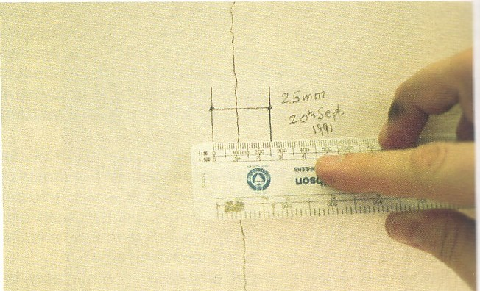
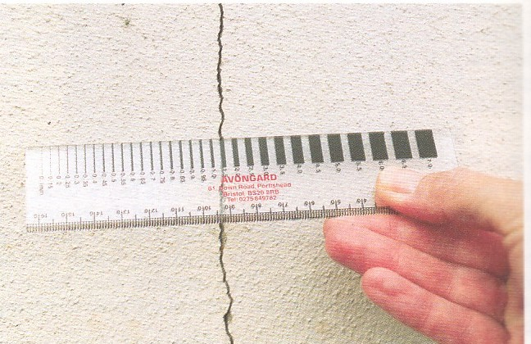
Fig 1 measurement using pencil marks Fig 2 measurement using a crack
measuring gauge

- Steel rule - crack widths can be measured to the nearest 0.5mm using a steel rule. However, because the readings tend to be subjective and it is difficult to ensure that the crack is measured at the same point each time, this method is normally used only for recording the state of damage during the initial inspection.

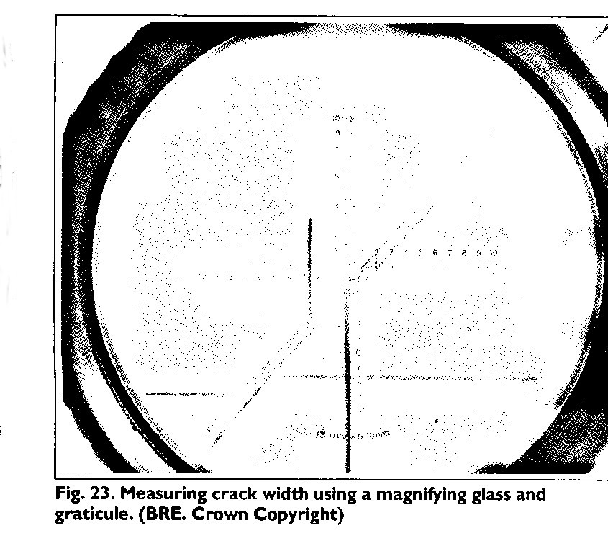
fig 3

- Magnifier and graticule - Internal cracks in plaster or other smooth finishes can be monitored by measuring the offset between two pencil marks using a magnifying glass fitted with graticule. With care, movements can be measured to an accuracy of 0.1mm.(fig 3)

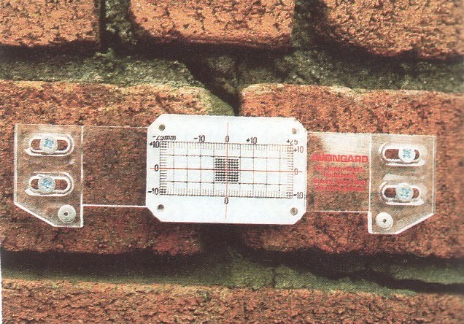

Fig 4 Crack monitoring using a plastic tell-tale

- Plastic tell-tales (fig 4) - The most popular system. It consists of two overlapping plates screwed to the wall, one marked with a cursor, the other with a scale graduated in millimeters. The two plates are mounted on opposite sides of the crack so that the cursor is initially in line with the center of the scale; any subsequent movement of the crack can be measured to the nearest millimeter on the scale. The advantage of this system is that a reading can be taken at any time by anyone, including the occupiers, without any additional measuring equipment. The disadvantages are that the tell-tales are relatively obtrusive, vulnerable to vandalism or accidental damage, and have only a limited accuracy. In general, they should be used only in conjunction with a more accurate method, such as the ‘Demec’ or ‘brass screw’ techniques described below.

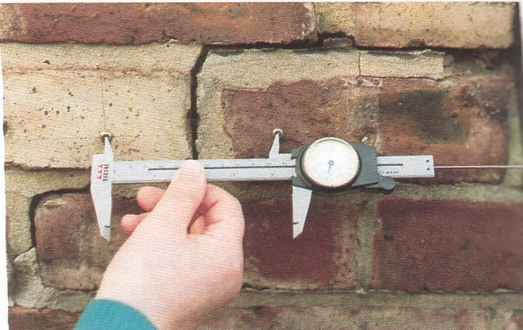

Fig 5 Demec studs with gauge

- Demec points (fig 5) - Two small, dimpled stainless steel discs are fixed on opposite sides of the crack. The distance between them can then be measured very accurately with a separate, hand-held instrument called a ‘Demec’ gauge. This gauge was developed for measuring very small movements – as little as 0.02mm – in concrete and masonry in laboratory tests. A disadvantage is that it is so accurate that it will also detect movement due to changes in temperature and moisture in the brickwork, which can confuse the picture. Demec points have the advantage of being very unobtrusive, but they are only suitable for use on a flat surface and cannot be used to measure cracks at corners. The main disadvantage, however, is the limited range of the gauge : the maximum extension that can be measured is 2.4mm and the maximum contraction 1.6mm. Where significant movement is occurring, it will be necessary to install replacement discs at intervals to allow readings to continue.

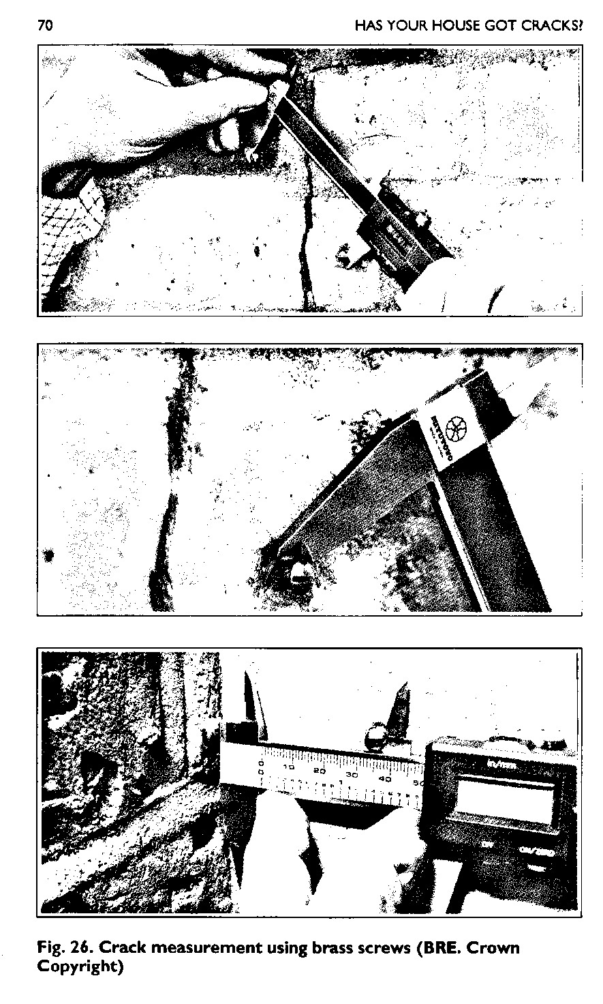
fig 6

- Brass screws (fig 6) - The technique recommended by BRE is to fix small brass screws into the wall either side of the crack and to measure the distance between them using a caliper. This system has the advantages of being simple, robust, relatively unobtrusive and, by using the calipers in different modes, capable of measuring cracks in corners and other awkward positions. If three screws are arranged in a right-angle triangle, both horizontal and vertical movements can be measured. With a digital caliper, an accuracy of better than 0.1mm overall should be easily achievable.

(2) Monitoring done at sites:
Monitoring levels
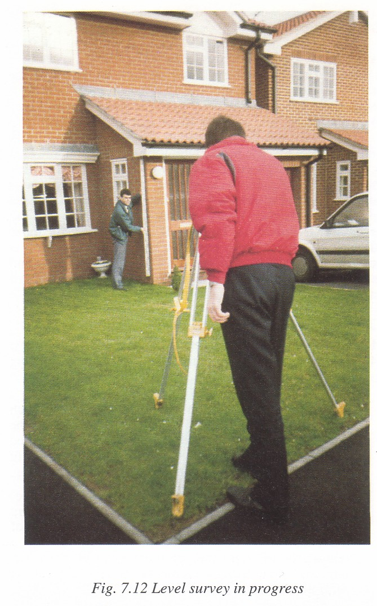
Once a crack is formed, stresses in the masonry from other causes, which in themselves were not enough to cause a crack, will redistribute themselves and may widen the crack, even though no further foundation movement has taken place. Hence, in most cases, it is better to measure the vertical movements of the foundations as well as crack widths.

This can be done using a precision optical level to record the movements of monitoring points fixed to the building. It is essential to use a precision instrument for these measurements to achieve an overall accuracy of + 0.5mm. For most applications, small screws or masonry nails can be used as monitoring points; these are normally sufficiently unobtrusive to avoid acts of vandalism.

Wherever possible, levels should be measured relative to a fixed reference point or datum. For most domestic applications, a storm-water drain or similar deep feature is sufficiently stable for this purpose. Where there are no deep drains or where absolute accuracy is imperative, a deep datum can be specially installed at a suitable depth.

Monitoring lateral movements

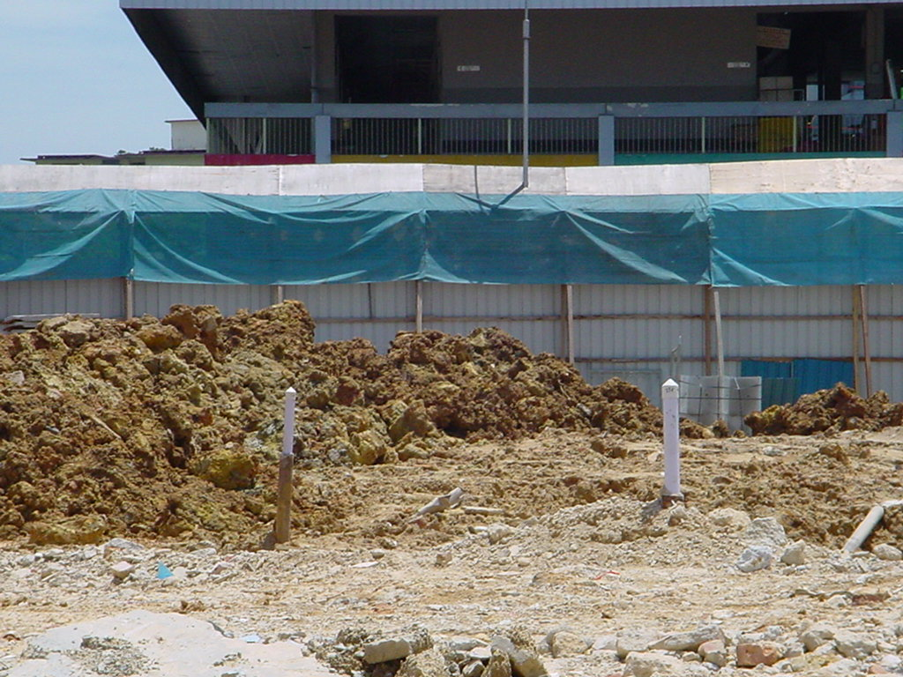 inclinometer

Lateral movements in shrinkable clays are rarely measured because of the costs involved. The usual technique is to install a special plastic tube in a borehole about 15m deep. Movement of the tube from the vertical can then be measured by lowering an inclinometer down the tube. The technique is highly specialized and should only be performed by a firm with the necessary expertise.

Differential settlement monitoring instrument in industry:

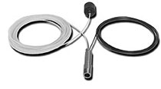
The FO-SSG Fiber-Optic Soil Settlement Gage is used for a wide range of applications including the monitoring of settlement for the control of road embankments, dams, and other earth works, the measuring of settlement or heave of building foundations, oil tanks, piers, and other structures, and the control of mining induced subsidence. It provides a simple-to-install, easy-to-use, high-resolution means of measuring differential settlement.
The FO-SSG consists of an all-stainless steel Fabry-Perot interferometric fiber-optic pressure transducer housed in a corrosion-resistant stainless steel body. The housing is attached to a base plate and connected to a reference station by a liquid-filled nylon tubing fitted with stainless steel connectors. The reference station consists of a sealed liquid-filled reservoir open to atmospheric pressure and located at a known elevation. The settlement or heave is measured with respect to the elevation of the reservoir.

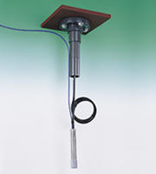
Model 4600 Settlement Sensor
The Model 4600 Settlement System is designed for the remote measurement of surface or subsurface settlement in fills, surcharges, dams, embankments, etc. A borehole is drilled which allows a Pressure Transducer to be anchored to solid ground below the area of settlement. A fluid-filled tube extends upward connecting the transducer to a reservoir which is located in the moving strata or fill. The measurement of fluid pressure indicates the elevation difference between the sensor and the reservoir. This design eliminates the need for long liquid filled tubes.

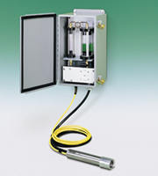
Model 4650 Settlement Sensor
The Model 4650 Settlement System uses a Pressure Transducer attached to a settlement plate located in the settling ground. The sensor is connected, via two fluid-filled tubes extending laterally, to a reservoir located on firm ground away from the area of anticipated movement. Fluid pressure within the tubes is sensed by the transducer which provides a measure of the elevation difference between the sensor and the reservoir. The tubes are flushable. The closed loop vented transducer/reservoir system is not influenced by barometric pressure.

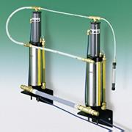
Model 4675 High Sensitivity Settlement Sensor
The Model 4675 Settlement Monitoring System consists of a series of vessels containing liquid level sensors interconnected by a liquid filled tube. A reference vessel is positioned at a stable bench mark location with additional vessels positioned at different locations at approximately the same elevation. Differential settlement or heave between any vessel and the reference vessel results in an apparent rise or fall of the liquid level in that vessel. This system is particularly suitable for critical situations where high resolutions are required. Elevation changes of as little as ±0.02mm (±0.001in.) are detectable.

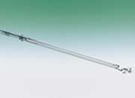
Model 6302 VW Horizontal Inclinometer
The Model 6302 Vibrating Wire Horizontal In-Place Inclinometer is used in conjunction with inclinometer casing installed horizontally for the measurement of vertical displacement (differential settlement). It is designed to be left in place inside the casing to permit automatic or continuous monitoring over extended periods of time. Strings of sensors can be joined together to obtain settlement profiles.

Modification Method for differential settlement :

Controlling the differential settlement of a building with a flexible concept and reliable technology :
- Because of the nonuniformity of ground settlement, buildings resting on reclaimed ground have various undesirable factors. Thus, a method for rectifying this situation is needed.

- The present method for rectifying uneven settlement can be used to provide firm support for buildings, even in extremely soft ground where several meters of settlement can be predicted. The settlement of a completed building is monitored and is rectified if differential settlement occurs. After years of acquiring experience and know-how in this field, in 1994 Takenaka won the prestigious Achievement Prize of the Architectural Institute of Japan.

- This new method for rectifying uneven settlement is an integrated method comprising four subsystems: 1) highly accurate settlement prediction, 2) reduction of differential settlement, 3) automatic settlement measurement, and 4) differential settlement rectification.

- The settlement of a completed building is monitored and is rectified if differential settlement occurs. This modification method for differential settlement is an integrated method comprising the four subsystems mentioned above.

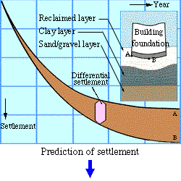

The difference between settlement of a building at the edge (A) and the center (B) often causes damages to both the functional and structural aspects of the building. This amount of differential can be accurately estimated..
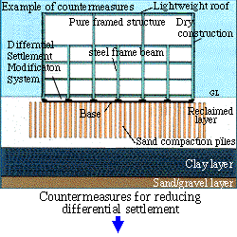

Measures to decrease the difference in settlement are provided in the ground, the foundation and the upper structure.

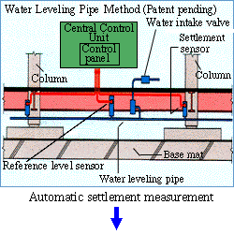
The amount of differential settlement after a building is completed is automatically measured and controlled from a central monitoring room.

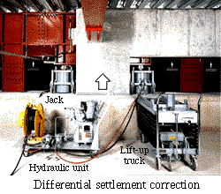

When the difference exceeds the control value, the building can be returned to an even horizontal position by using hydraulic jacks fitted to the column bases and can be interfaced to maintain this integrity under reaction force.

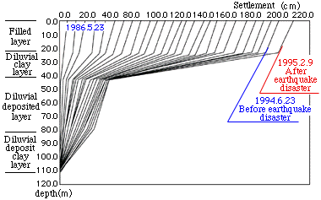

Example of ground settlement observation
(Rokko Athletic Indoor Hall at Konan University)

- This method has been applied to a total of nine projects so far, including the artificial island of the Kansai International Airport. Of these, six were been built on Rokko Island, which sustained much ground settlement as a result of the 1995 Great Hanshin Earthquake. Despite this settlement, all six buildings have remained stable, proving the seismic resistance of this new method.


Rokko Athletic Indoor Hall at Konan University
Hyogo (Completed in 1986)
Design : Takenaka Corporation
Total floor space : 5,309 m²
Number of floors: 2 above ground


Canadian Academy
Hyogo (Completed in 1990)
Design : Takenaka Corporation
Total floor space : 15,360 m²
Number of floors: 4 above ground


Rokko Distribution Center in Ryoden Unyu
Hyogo (Completed in 1989)
Design : Takenaka Corporation
Total floor space : 21,898 m²
Number of floors: 6 above ground

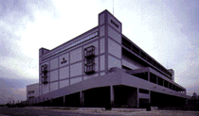
Morimoto Warehouse on Rokko Island
Hyogo (Completed in 1990)
Design : Takenaka Corporation
Total floor space : 33,861 m²
Number of floors: 5 above ground

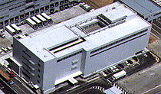

Royal International Air-Catering Co., Ltd.
Osaka (Completed in 1993)
Design : Takenaka Corporation
Total floor space : 15,501 m²
Number of floors: 6 above ground

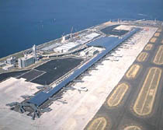
Passenger terminal building of Kansai International
Airport
Osaka Prefecture (Completed in 1994)
Design: Renzo Piano Building Workshop Japan
(Renzo Piano + Noriaki Okabe)
Total floor space : 291,269 m²
Number of floors: 1 below ground, 4 above ground

