THE OUB TOWER
Introduction
The OUB Tower is situated in the Central Business District. The Tower consists of 62 storeys and was completed in 1986.
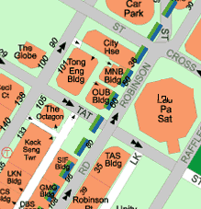
OUB Tower
Location of the Tower

Soil Characteristics
In this project the subsurface soil consisted of hard bouldery clay up to a depth of about 100m. Then there is bedrock which consists of interbedded siltstone and sandstone, moderately to slightly weathered.

Foundation Type
The Tower was built on seven large diameter caissons. Four of the caissons are of 6 m diameter and the remaining three are 5 m in diameter. The caissons are built to be end-bearing and the skin friction from the bouldery clay (though it might not be insignificant) was neglected. They therefore, extend through the bouldery clay and rest on large bases ( 6.5 m to 11m ) in the bed rock..
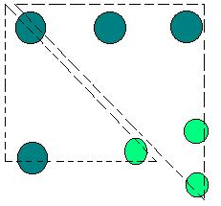
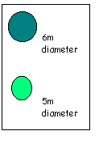
Layout of caisson foundation.
Construction of caissons
Open shaft mining technique was used during the excavation. The caisson was lined through the bouldery clay and the belling out was entirely in bedrock.
During the excavation in the bouldery clay, a mini backhoe was used. The boulders were removed by blasting.
Water seepage in this project also was not a problem.
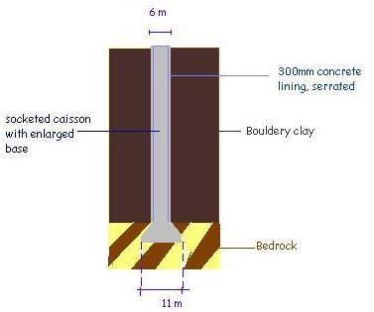

The lining consisted of 300mm cast in-situ concrete. It was installed by excavating ahead for 2 m and then placing a segmental circular steel formwork. Concrete for the lining was then poured using a rolling concrete hopper bucket. The lining slants inwards and downwards, giving it a serrated surface

The bell was constructed by first excavating four headings at the end of two perpendicular diameters. The headings were 2m wide and 1.5 m high and were cut through the lining and extended to the edge of the required bell.
Five levels of such headings were constructed with the length of the headings decreasing towards the top.
The concrete used for the shaft was of Grade 30 and reinforcement steel was placed along the perimeter and extended the full length of the shaft. The reinforcement was heaviest at the caisson base. The concreting was carried out in lifts of 10m high using a 2m³ bucket and chute.

