THE REPUBLIC PLAZA

Introduction
The Republic Plaza is located at the Raffles Place. It is a 66-storey building with a total height of 280m and a 9-storey podium.

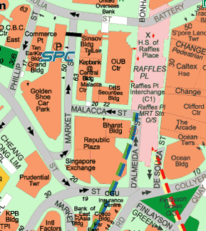
Republic Plaza

Soil conditions
The subsurface soil profile consists of:
- 2.3 m to 3.4 m of fill with a water content of 30% to 35%
- 1.1 m to 4.2 m of loose sand and/or soft marine clay. The water content in the marine clay is about 50%
- Bouldery Clay formation
- Jurong formation which consists of alternating layer of shale, sandstone, siltstone and mudstone. Many faults were observed in this formation. The upper part is heavily weathered. However, the sandstone is generally stronger and less weathered than the remaining layers.

The ground water level varied from 1.1 m to 1.7 m below the ground surface.
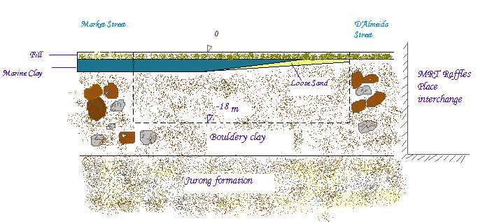
± 0 m

Soil condition at cross section

Foundation design
The site is especially confined being in the CBD and within 6m from the Raffles Place MRT Interchange. Because of these constraints special precautions had to be taken during the excavation.
The foundation system consists of fourteen 5 to 6 m diameter caissons and around 900 small diameter high capacity micropiles. This foundation system was chosen because of the soil conditions as well as the presence of old piles.
Temporary support.
The temporary support consisted of removal ground anchors, contiguous bored soldier H-Piles as retaining wall. Grouting was also conducted to prevent excessive ingress of water.

Construction of caissons
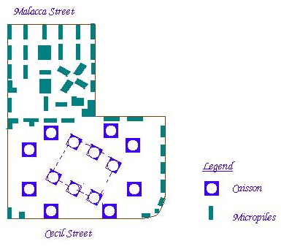
The 14 caissons together with the micropiles support the 66-storey tower block. The 14 caissons were constructed at the same time. They are actually deep shafts. Each caisson took about 8 to 25 week depending on the length of the caisson as well as the boulder content.
The caissons were excavated in 2m lifts. Blasting was used to break the hard sandstone boulders and to loosen the hard clay between the boulders. The blasting operations had to be closely supervised to reduce disturbance to the surroundings.
The loosened materials were excavated using a mini excavator. Then a 35-grade concrete lining was cast to support the wall. The reinforcement was continuous except at the jacking test locations and the maximum excavation level below the completed lining was 3 m to prevent collapse of the wall.
A 3m concrete plug was cast after the excavation was completed. The caissons were cast in the dry in one continuous pour using a vertical chute which was kept as close as possible to the surface of the concrete. Vibrators were used to compact the concrete after the casting. Low heat cement was used for the caissons to keep the maximum temperature below 65°C and to limit the maximum difference between centre and the perimeter of the caissons to 20°C in order to prevent cracking of the concrete. Chilled water was used to control the temperature.

Construction of the micropiles
The micropiles are small diameter prebored grouted piles that carry the axial load mainly by skin friction. The grouted pile is substantially reinforced with four 40mm diameter steel reinforcement to increase its structural capacity in compression. Usually the steel reinforcement ration is around10%. The maximum length of the micropile was 19m.
Micropiles were used for the project because of the presence of numerous boulders and existing piles. Micropiles are especially useful in these situations as they can be easily repositioned if there are existing piles in position. The use of micropiles would also enhance the speed of construction.
The boreholes for the micropiles were drilled using a down-the-hole hammer. Compressed air was used to remove the cuttings to prevent the softening of the clay during the drilling.
Within the MRT reserve, the micropiles were later debonded to prevent transfer of load to the tunnel.

