National University of Singapore
SCHOOL OF DESIGN AND ENVIRONMENT
DEPARTMENT OF BUILDING

BU 3107: CONSTRUCTION TECHNOLOGY IV

Q. Discuss the use of system formwork (climbing, flying etc) for wall and floor construction. Show details with case studies.

A) INTRODUCTION

System formwork is a new development of unconventional formwork method. It is usually large panel formwork that is best suited for use in high rise multi-storey buildings such as hotels and apartment buildings, where many reuse are needed. A breakdown of classification of the common types of system formwork is as follows:

System Formwork

Vertical Formwork
Horizontal Formwork
1) Wall
2) Jump

1) Slip
2) Self-climbing
1) Flying/table
1) Full Tunnel
2) Half Tunnel
Crane dependent

Crane independent

Vertical Formwork
Tunnel Formwork

B) CRANE DEPENDENT SYSTEM

System formwork can be generally classified into crane dependent and crane independent system.

These can be further classified into 2 main categories, ie vertical and horizontal system.

Vertical system formwork is used to form the vertical supporting elements of the structure – column, core walls and shear walls. The functions of the vertical supporting systems are to transfer the floor loads to the foundation and to resist the lateral wind.

B1) JUMPING FORMWORKS

Introduction

Jumping forms or climbing forms are forms which are continuously moving while the concrete is being placed but are forms constructed in successive lifts and supported by previously poured lift.

This is a method of casting a wall in set vertical lift height using the same forms in a repetitive fashion to obtain maximum usage from a minimum number of forms. Furthermore, it is to restrict the development of high pressure that would occur if the wall were casted in one pour.

The basic formwork is shown in Diagram, which, in the first lift, is positioned against the kicker in the inverted position. The concrete is poured and allowed to cure after which the forms are removed, reversed and fixed to the newly cast concrete. After each casting and curing of concrete, the forms are removed and raised to form the next lift until the required height has been reached.

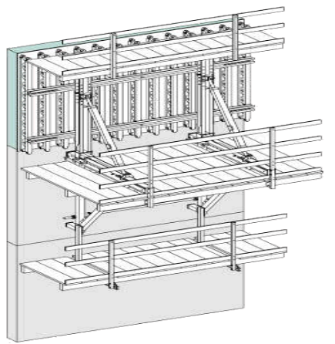
PERI SKS system

Doka Formwork K

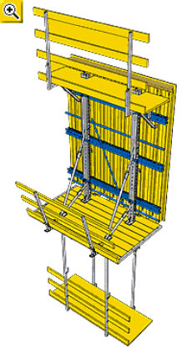

Basic requirement

The basic requirement for a system of jumping formwork can be listed as follows:

a. A mean of adjustment for leveling and plumbing the forms.

b. Easy means of striking the formwork.

c. A mean of providing working platforms to give freedom of movement similar to condition on ground.

d. Means of lifting the forms by crane, removing and repositioning so that it will be able to receive the next concrete pour operation.

e. Means of securing and tying the forms.

Construction Method

A typical erection method for jumping form is having steel or wooden wailing backed by steel soldiers and jointed together using keys and wedges or means of universal clamps. Plywood is then nailed or screwed onto the walings and the formwork is then ready.

The positioning of both the soldiers and walings are calculated by the manufacturer; all the workers are required to do are to erect the formwork as specified with the aid of an experienced supervisor to ensure the smooth progress.

Due to the fact the members are jointed together with simple to operate devices, the speed of erecting this kind of system is very fast and the required manpower also reduces, Hop-up brackets are also fixed to the top of the soldiers to create a working platform of 3 board wide. They incorporate a socket to take a guard post of standard scaffold tube. A guard rail of standard tube with scaffold fittings for attachment and a toe board completes the platforms.

Lifting brackets are also bolted to the top of the soldiers at pre-selected point to facilitate lifting.

As for holding the formwork in place, the reusable tie system with a complete range of accessories including thrust plates, wing nuts, plastic spacer tubing and plastic cones are being used. The 15mm nominal diameter tie rod has a robust, self cleaning thread and a safe working load of 127kN ensures easy retrieval and strength.

Sequences of operation

To ensure that the system is properly set up to give a quality finish, the following steps should be taken:

Operation 1

Assemble the forms for pouring the initial height of the wall, positioning the ties at appropriate level for connection of the suspension brackets needed for the next operation.

Operation 2

After striking and cleaning, assemble the climbing bracket on the suspension brackets fixed to the upper ties of the initial pour. Crane the formwork units into position and locate the upper ties as before for operation 3. After striking, open the forms for cleaning.

Operation 3

Lift the units, connecting them to the suspension brackets fixed to the ties of the previous pour and bolt on the lower climbing brackets if required.

Close the forms for pouring. The assembly is now complete for operation for all subsequent pours.

Operation 4

Repeat operation 3 for subsequent levels with occasional cleaning and oiling to the plywood.

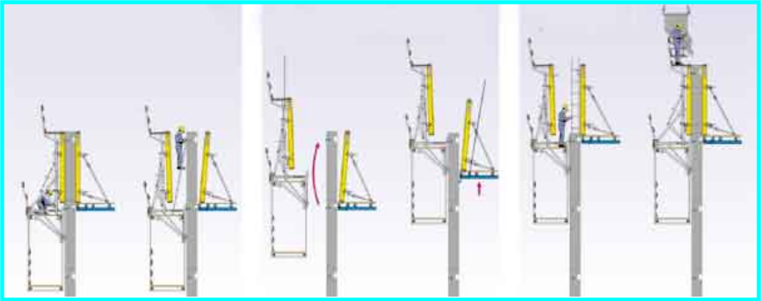
Striking
Remove anchors
Release the wedges of the vertical waling Retract the formwork by turning the spindle
Screw in the suspension cone
Lifting
Lift external climbing unit
Only 5 to 10 minutes crane time per lift
Lift the inside shaft formwork
Formwork erection
Plumb inside formwork
Place the reinforcements
Close outside formwork
Pour
Advantages

There are various benefits that can be obtained from using this kind of system and they are as follows:

- As this system is relatively simple to erect, it reduces the time taken thus a reduction in construction time can be obtained.

- Less manpower is required for erection of this system.

- Refabrication of the formwork is approximately nil except occasional change of plywood.

- Superior finish can be obtained from this kind of system.

- Working platforms fixed to the system allows the work to be done.

- Formwork is fully adjustable for leveling and plumbing.

- The components are strong and robust.

Disadvantages

This system is just like the table form and also suffers certain disadvantages and they are as follows:

- It suffers from high initial capital cost.

- As it is not self climbing, the crane is needed for lifting to next level.

- As this system relies on the crane heavily, proper planning must be done to ensure the crane is available to prevent any hogging of work.

Problems encountered utilizing jumping form

Handling problems

During lifting of the jump form from one level to the next level, securing the lifting cables is essential. Furthermore the crane operator has to be able to lift them to the required position.

During windy days, swaying of the formwork posed a danger to people and structure when it was lifted thus care had to be given.

Crane height

Theoretically jump form can work independently regardless of the storey height being built and should finish well ahead of the floors. However presence of climbing tower carne standing a few storey above the finished floor level can hindered the progress of the core wall.

Boxing up

As openings must be catered for different services pipes or wirings in the core walls, they must be boxed up prior to concreting. Although it is inevitable to do so, reference to the consultant structural engineer has to be made as they might not agree to have a box up at certain locations. IN some instances, they allowed boxing up to a certain depth of the wall without penetrating through it. Therefore before any boxing up, meetings were held with the consultants to get permission to do so.

Position of tie rods

Due to the facts that the position of the tie rods are fixed, this did not facilitate flexibility in shifting them in cases where they hit the rebars, this pose a problem as the rebars need to be shifted to cater for the tie rods.

A moveable tie rods are recommended whereby tying position can be shifted horizontal to avoid hitting the rebars.

Bending of rebars

The core wall is jointed to every level of the buildings, thus this means that starter bars need to be fixed to join the rebars of the slab. During concreting, this portion besides requiring boxing up, the rebars also needed to be bent. Sometimes congestion of rebars occurred or during the straightening of the rebars, leading to loss of bondage with the concrete, thus resulting in a poorer structure.

The above are actual problem encountered on site. They can be solved through proper planning, coordination, precaution and training. If not, some alternative means such as using other kinds of formwork, must be developed to solve the problems.

B2) TABLE FORM SYSTEM

Introduction

The term “table” originated with respect to framed arrangement of formwork that were sued to form soffit to floors and flat slabs. It is also commonly known as flying forms. It is developed as a rationalized method of in-situ concrete construction which aims at eliminating the time and labour required to erect and dismantle the panels by creating a system of formwork which can be struck as an entire unit, removed, hoisted and repositioned without any dismantling.

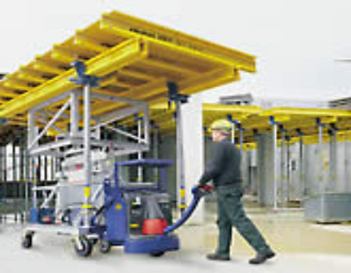
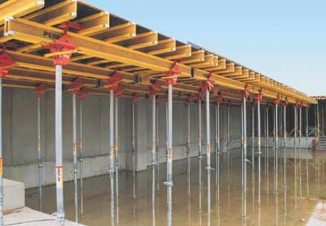
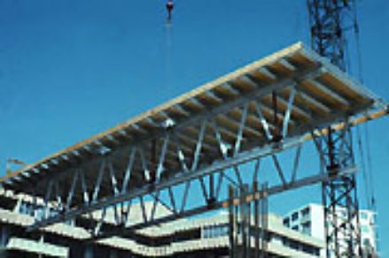
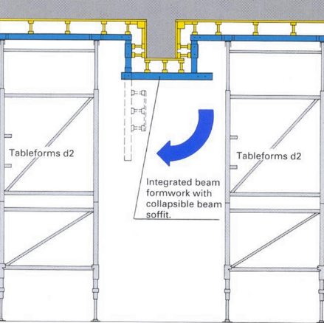
Symons Flying Truss System

Doka Load Bearing Tower d2

Dokaflex tables

Peri Girder Slab Formwork

Component of Table Form

A table form consists of a large form surface which is supported by a system of channels and vertical framed falsework which can be lowered when stripping, and raised to the correct position during erection. The form faces may be formed by large sheets of high quality plywood or steel panels connecting together.

Some rolling system are attached to the table or placed under the table or on the concrete floor. This allows the table to be rolled to the edge of the building for the flying operation. The table can be flown to the next position using a C hook or by re-slinging. A crane of sufficient capacity is required.

Development of Table Form

The earliest table forms were made up from combination of inverted steel props, scaffold tubing and scaffold castors and although they did the job, they were clumsy and sometimes dangerous. They have today been replaced by a number of patented systems. Some of these rely on a horizontal U shaped lift beam which hooks under the slab, retrieves the table form and lift it to its next position. While some uses a right angled beam truss which locks on the table form to make it, in principle, U shaped and the U outline is to make a connection to the center of gravity above the floor which has been concreted.

Good supervision is required for operatives safety and to prevent the table form from exerting any vertical force on the soffit of the new slab. The erection of the frame of Table formwork must be accurate to ensure a quality formwork. An experience supervisor with the technical knowledge should be around to ensure that the formwork is properly erected.

Requirement of Table Form:

Some of the basic requirements for the use of table forms are as followed:

- A mean of adjustment for aligning and leveling the forms.

- Adequate means of lowering the forms so that they van be dropped clear of the newly cast slab. Generally the provision for lowering the forms can also be used for final leveling purposes.

- Means of manoeuvring the forms clear of the structure, to a point where they can be attached to the crane for final extraction, lifting and repositioning so that it is ready to receive the next concrete pour operation.

- A mean of providing a working platform at the external edge of the slab to eliminate the need for an independent scaffold which would be obstructive to the system.

The size of the table depends on the following factor:

- The area and dimension of the slab to be formed
- The structural system
- The lifting capacity of the crane
- The size of the exit for the table during flying operation

General features of Table Form:

There are many proprietary system of flying forms available in the market. All of them give a great variety of choices to the builders. However all formwork consist of the following units which can be combined to form a finished formwork element.

1. Sheathing panels provides a mirror of the finished concrete surface and are the form in formwork. All other parts merely support this form.

2. Supporting units come with straight legs, lattice legs or transverse frame. It is built up to give a wide variety of adjustments for height, carrying long timber beams which support the decking tied together longitudinally by a number of cross braces. The frames are made up of 4 units:
a) Base units, b) Adjustable puncheon frames, c) Fork Head, d) Wheel frame

Flying Sequences of Table Form:

To lift the table form from one level to another, the following flying sequences should be followed (Diagram 2.1, pg 13)

Step 1:

Ensure nothing is obstructing the flying of the table form. To fly the table form, the Universal Trolley is fixed onto the formwork, the adjustable jacks are then released and retracted in to the vertical to facilitate movement. At this point, the table form is lowered and fully supported by the Universal Trolley. A piece of timber restraint is also fixed at the edge of the slab to prevent any damage to the concrete during flying and for stopping of the trolley.

Step 2:

After the table form is lowered and ready to fly, it is pushed outward as indicated. The tower crane’s lifting hook with 2 cables is used to lift the table form.

Step 3:

Cable 1 is then fixed to the external lifting points of the table forms. It is then pushed further out until the trolley wheels hit the timber restraint. This trolley is then removed. A cable restraint is then fixed at the internal lifting points to prevent any sudden swing by the crane and cause the table form to be pulled out.

Step 4:

When the table form is in a balanced position and ready to fly up to the next floor above, the last set of trolley will be removed when it hits the timber restraints at the edge of the slab. The table form is then flown up to the next floor and placed in position. The adjustable jack is then released and the height is adjusted correctly.

During the flying of the table form, some risk factors are inherent such as the crane may move too suddenly and create a sudden pull. Thus workers involved should be well trained and a supervisor should be around to direct the operation. Furthermore, all safety precautions such as wearing safety belts, gloves etc should be taken.

The table form works on a 7 day cycle for each floor with an area of 1300m2. If required, after the table form is removed to the upper floor, temporary back propping can be fixed to ensure the concrete will be able to gain sufficient strength.

Construction procedures

Dismantling and erection

Tables forms are lifted and placed on the existing floor slab. One unit of table form is erected first and ready for reinforcement operation which the erection of the table form for the adjacent unit is just about to start.

Reinforcement and oiling

Mould oil is sprayed over the table forms, followed by fixing reinforcement. BRC meshes are replaced and fixed on the first unit of table form and ready for concreting while the erection of table forms for the adjacent unit is just completed.

Concreting

While the first casting operation is carried out, the reinforcement operation is done simultaneously to adjacent unit in preparation for the second casting.

The construction procedures are repeated for subsequent.

Jointing

The gap between RC wall and the table form is filled with gypsum plaster. For larger gaps or openings, Styrofoam is used.

Surface finish

Film base plywood decking of the table form produces smooth slab soffit which require no plastering. Top surface of the slab may just require screeding.

Advantages of Table Form

This kind of table form system enjoys many advantages which are listed as follow

Speedy erection and dismantling

The supporting frame is permanently attached to decking thus saving the time of stripping individual parts as it being done in tradition formwork system

Repetitive operation

Table form is used for identical cell structure which permit repetitive operation to be carried out without major modification of the dimension of the form. Maximum number of re-use is achieved.

Flexibility and versatility

Individual tables can be joined together by means of locking devices to cover wide spans and inter-column beams or slab section, ring beams etc. can be incorporated in the table form for simultaneous casting with the slab.

Smooth concrete surface

Steel or plywood based table form produces better quality concrete surface than any other types of formwork system.

Reduced wastages

Practically no wastage occurs except fair wear and tear of sheathing after a number if projects.

Better planning and control

Planning of table form and its subsequent control are easy as its dimension is based on modular system. Quantitative analytical work is substantially reduced.

Minimum storage area

Continuous use of table form is the main criteria in achieving economy. Almost every unit of the form will be out down to use after it is dismantled from the work place. Only minimum storage area is allocated for maintenance and repair purposes.

Clean work area

Large working space is available below the table form for ease of operation. Nails, hammers, scrap pieces of wood on the floor, as are common in traditional timber form, no longer exist.

Mobility

Wheeled frame allows horizontal movement of table form and tower crane helps the vertical movement of the form. Both operations can be done in 5 to 10 minutes times for an area of about 27m2

Minimum labour

The mechanical system of construction inherent in table form reduces skilled labour substantially.

Lower running cost

This is evidenced form the maximum number of re-use and minimum skilled labour required.

Safety

Stable framed propping units and rail brackets fixed to the edge of table form allow workers to work safety.

Disadvantages of Table Form

Despite having all the abovementioned advantages, this system also suffers from some short-falls which can be listed as bellows:

- It suffers from the common problem of high initial capital that needed to be invested.

- It can only be used repetitively for similar design slabs.

- Proper planning and site organization is required to prevent any congestion on site.

- The length if this system is limited by the length of the primary bearer which is usually up to 40 feet (length of container)

- As it relies on the crane for flying, coordination between different trades for the use of the crane is critical.

From the above, we can see that although this system suffers from some disadvantages, it is still a very good system to be utilized from all the advantages it enjoys.

Other function of Table Forms

Table forms are sometimes used to support temporary moulds for waffle slabs. The table provides flexibility for laying the moulds. This additional flexibility causes table forms to be popular among contractors as the saving in time and labour can be as high as 50%. However the actual amount of saving depends on the amount of variation in the size and shape of each floor slab; the type of structural system used and the ability of reinforcement and concrete work to catch up with the progress of the formwork.

In practice, contractors often encounter difficulties in incorporating beam forms with the table form. It is difficult to lower the beam form simultaneously with the table form as the sides of the beam form tend to be stuck to the concrete.

This problem can be overcome if beams are designed with a shorter depth and with a slightly tapered cross-section. Due to the difficulty in changing the beam designs, contractors usually restrict the use of the table form to slab only.

Different types of table forms are developed. They differ mainly in the falsework systems used. These different systems are described in the following tables:

TYPE | DESCRIPTION
Framed Falsework System | Prefabricated H frame scaffolding falsework is used. Two to four sets of the H frames may be used depending on the size of the table. They are braced together to ensure rigidity. The form face is formed by steel panels connected together or plywood sheetings.
Folding Shores System | Telescopic steel shores are sued as falsework. A minimum of four shores is required. The form face is the same as the previous system. During the stripping the shores are lowered together and folded up before it is moved to the position for flying. Therefore it is suitable when the height clearance is very low.
Shoreless System | No falsework is attached to the table. Short shores are fixed to the columns or load-bearing walls, which support the table. Thus the columns and walls are cast 3 to 5 days before sufficient strength. Large steel sheathing is used for the form face.  During stripping the shores are lowered which allow the table to be lowered. A C hook is used to fly the table to the next position.
Trussed System | Two or three sets of trusses are sued as falsework. To allow height adjustment, short telescopic legs are fixed at the bottom of the truss.  Aluminium is usually used for the truss.  Large plywood sheathing is used as the form face which is supported by a system of C aluminium channels.

B3) TUNNEL FORMS

Introduction

The most outstanding development in formwork technology is the development of the full tunnel systems, whereby walls and slabs are concreted in the operation.

They are used as a fast method of erecting multiple cell structures or shear wall structures. Besides they are used mainly for unit blocks in standardized flats for forming bulkheads or unchanging larger tunnel sections with few or hardly any adjustment areas.

Tunnel forms have been well established and prevalent in most European countries for many years, but they have not gained much popularity in local construction industry because they are introduced to Singapore only a few years ago. They need time to show their ability in achieving a sound and economical building construction.

Types of Tunnel Form

There are 2 main groups:

a) The complete tunnel which consists of two wall faces and an interconnecting slabform;

b) An half tunnel which consists of two inverted ‘L’ shaped angles locked together.

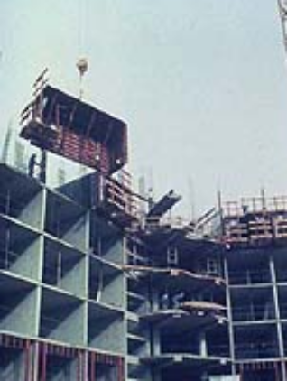

Symons Room Tunnel System

Half Tunnel Form

IN this type of formwork, they are 2 right-angled shutters arranged horizontally as shown in the diagram. When assembled, this tunnel comprises two walls and the ceiling for a room. The joint in the crown of the slab can be achieved by two angle-pieces placed flange against flange. (as indicated in the diagram).

Full Tunnel Form

As the name implies, it is a kind of formwork which comes with a single unit including shutters on both sides and table formwork horizontally.

The slab formwork is fitted with jacks and rollers and includes a horizontal adjustables bar on both sides, so that the two vertical shutters can be brought together once they have been struck by means of slots which receive the fixed axles on the vertical shutters (as indicated in the diagram).

In the struck position, the vertical shutters remain attached to the slab formwork. The whole is handled and transported to the next cell by a balanced arm or tablelifting hook.

Major difference between the 2 types of forms is that full tunnel forms are not constructed in phases but at one go for each floor slab. Full tunnel forms are generally larger in size than half tunnel due to different design requirement of the buildings.

Work cycle for half tunnel

Forms assembling

Half tunnels are lifted by stationary or movable tower crane to the first 4 units. This operation together with fixing and clamping takes about 3 days to complete. Reinforcement is then placed on top of the tunnel form. This operation takes one day to finish. Concrete is done for another 1 day.

Forms dismantling and transfer

Once the concrete is sufficiently cured, the forms are removed. The tie rods are removed and cleaned of any concrete. Then the heavy duty latches holding the ceiling sections together are opened and stop-ends are detached. The dismantling operation requires the whole work force. After this, the lifting hook attached to the crane is fixed into the lifting socket and secured tightly to the half tunnel form units. Diagonal and vertical supports are loosened and lifted off the supporting floor while the form unit is lowered clear of the ceiling and moved out the building to the next location for reassembly.

The transfer of the forms requires two men to remove the forms while the rest of the men receive the forms at their reassembly site.

Cleaning, oiling and assembly

The form unit to be fitted, is placed alongside its reassembly location for cleaning and oiling. The next form unit is placed in position, cleaned, adjusted for height, aligned in a true vertical position and oiled. When this is ready, the previous form unit is moved to its final position. Then the next form is lifted into its working position, the first tunnel is ready. Assembly continues in this way and when all corner forms are in position, the following work stage commences.

Bolting and positioning

When all form units are in place, tie bolt inserted and fitted out completed, the wall section are bolted together. The bolts are tightened pneumatically in such a way that the precise wall thickness is achieved and the form surfaces are tight and flush against the kickers and spacers. The ceiling section are aligned precisely and locked together with heavy duty latches. Cross spacers are used to ensure accurate casting of kicker and subsequent accurate alignment for the form assembly.

Reinforcement

After the previous work stage come the cleaning of the ceiling surface and oiling it. After that has been done comes the placing of the reinforcement, electric cable conduit, box-outs and other things which are to remain in the concrete.

The kicker forms are then assembled onto the cross spacers. A short length of BRC is protruding out from the hardened kicker. The next BRC for the succeeding wall is connected to it, followed by half tunnel forms which enclose the BRC. BRC for the next floor slab is then placed on top of the tunnel forms. Both ends of the walls are enclosed by stop plates.

Concreting

The walls and slabs are then casted and vibrated with poker vibrators to eliminate air pockets. The kicker form is filled and lightly vibrated immediately after the slab has been vibrated. The whole work stages is presented as following:

Surface finish

The surfaces of concrete produced by tunnel form are very smooth and need no plastering. However to give the surfaces a better quality, a Finish plaster “Vitonit” is used for plastering.

Safety

Fences and climber scaffolds are erected on all edges of the working decks. It is very safe to work on top of the tunnel forms.

Advantages

Tunnel form can give the builders the following advantages:

Low Long term capital investment

Although initial capital cost may seem high for most types of tunnel form, the low long term capital cost is worth the money spent due to the maximum number of reuse attainable.

Speedy erection and dismantling

The monolithic casting of walls and slabs at one go saves the erection and dismantling periods substantially.

Strong building frame

The use of tunnel form results in building which cross wall construction which can withstand lateral deflection and seismic disturbances.

Smooth concrete surface

Material used for tunnel form is invariably steel which provides smooth concrete surfaces without the necessity of plastering.

Improved sound insulation

Building constructed with tunnel form is seamless, solid and heavy, which greatly improves sound insulation.

Low labour cost

The number of skilled labourers is substantially reduced due to the simplicity of the construction method in tunnel formwork system. Cost attributed to labours also reduced.

Independence from weather condition

The erection and dismantling of tunnel form can be carried out at any time irrespective of inclement weather.

Neat working space

Supporting system if tunnel form is simple. Only a few trusses, braces and props are required and large spaces are left for labourers to work in.

Mechanisation and productivity

Tunnel form is fully mechanized formwork system which incorporates the use of heavy lifting equipment. Rate of work is fast and hence results in higher productivity.

- Minimum storage area is required.

All units of tunnel form are kept in use at any one time which improves in economy. In connection with this, practically no storage space for tunnel form is required except for those units which need repair and maintenance.

- No wastage

The use of steel tunnel form eliminates material wastage which is very common in traditional timber formwork system.

Industrialisation

Tunnel form is closely associated with industrialized method of construction. The formwork itself is manufactured with strict compliance with the modular system and standardized tolerances adopted internationally. Besides insitu slab and wall construction, it also necessitates the use of some precast units such as staircases, balcony and in some case toilets units.

Greater choice of materials for façade

The desired building façade can be chosen and attached to the permanent concrete frame of the building. Since the façade itself does not receive loads and stresses it can be made of light façade materials and in a form different from the rest of the buildings.

Safety

Tunnel form is strong in withstanding static ad impact load.

Disadvantages

Despite the numerous advantages given by the tunnel forms, it is not without any flaws:

High plant cost

Cost involved in either purchasing or hiring heavy lifting plant is very high. Economy can be affected by continuous flow of lifting operation without letting the plant standing idle. Thus planning of the operation is essential.

- High initial capital cost

This may deter the otherwise enthused contractors from using more efficient formwork system and mechanizing building work even though the cost in the long run is low.

Difficulty in repairs

The metal surface of tunnel form once dented or damaged would entail re-flattening or welding which proves costly and time consuming. Moreover, the whole unit keeps idling for quite sometime even just a little damage on its surface.

Susceptible to rust

Unless regular maintenance by oiling the surfaces of the forms, tunnel form rust easily.

Longer curing time

This was due to the large amount of concrete being cast at one time.

C) CRANE INDEPENDENT SYSTEM

Basically the system formworks are independent of the crane and are mainly moved either by labours manually or using hydraulic jets.

C1) SLIP FORM

Introduction

Slipform is a method used for tall structures which are constant in cross section such as silos or the service cores of buildings.

Construction sequences

Forms, usually 1.05m high are built rigidly to the desired shapes and held relative to each other by frames called yokes. They are adjustable and strategically placed so that it will give the form sides the rigidity needed and to apply the pressure required to produce a reasonably smooth surfaces. Hydraulic climbing jacks are mounted in the yokes within the concrete. The bottom ends of the form sheathing are slightly tapered in order to help make the forms self clearing.

A working platform is attached to the inner form and rides upwards with it. At the same time, a finisher’scaffold is suspended from the outer form so that the workers can finish the newly extruded concrete as it emerges.

Horizontal rebars are placed in the wall as required to the full height of the forms and the vertical rebars are allowed to extend to a convenient height.

The form is filled with concrete slowly and the forms are raised by the jacks after the concrete has partially set. All jacks are synchronized to operate equally and simultaneously. The verticality of the structure is monitored with plumbs, levels etc.

The system is no popular for buildings more than 30 storey as too many consumables are required as the operation is continuous. The continuous supply of concrete can also be difficult.

The success of slip form operation depends on good planning, design and supervision do that the operation may be as continuous as possible. The major factors contributing to successfully slip forms are as follows:

- The proper concrete mix design and careful compacting of the concrete to maintain the proper slump and sets.

- Adequate facilities for supplying for supplying concrete to the required height

- Supervisors who thoroughly understand the operation of the slip forms.

C2) SELF-RAISING FORM

Self-raising form or self-climbing formwork systems are very useful in congested site. The climbing rail acts as a ladder hooked onto the climbing shoe which is anchored to the wall for the elevation to take place. It is very similar to normal climb form except it has Hydraulic rams or jacks which are the mechanism that pulls the formwork system to the next level and raises all platform and platform areas.

Another difference between self-raising to slip form is that self raising forms are not continuously moving while the concrete is placed but are forms constructed in successive lifts and supported by the previous poured lift. In addition, the concrete finish resulting from self-raising form is of higher quality than the one produced by the slip form..
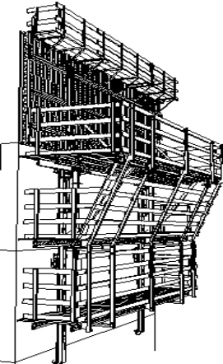
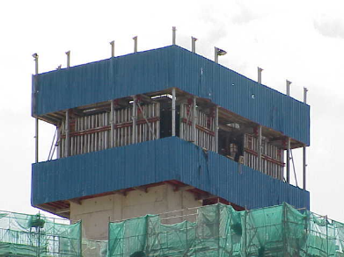
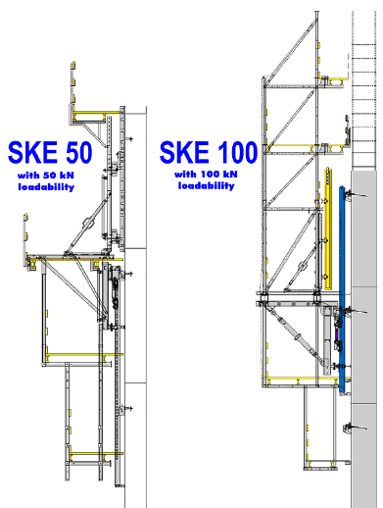
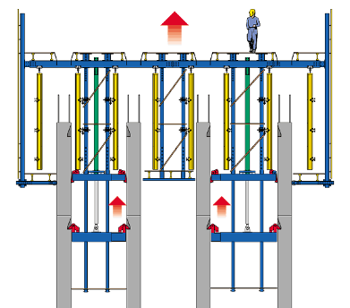
ACS Self Climbing Formwork

Lubeca Mark II Self Climbing Form

Doka automatic climbing formwork SKE

Doka platform SCP
Form

D) SELECTION OF SYSTEM FORMWORK

- Main formwork area

The system selected should be most suitable for the main formwork area.

- Initial cost

The system, which has low initial cost and low cost per use, will be an economical system. Cost is usually inversely proportional to quality, speed of erection and dismantling, labour requirement, number of reuses and maintenance

- Amount of labour required

The amount of labour required depends on the simplicity of the system. Mechanical handling tends to reduce the labour content. The system which uses the least skilled and unskilled labour and which makes use of existing handling equipment would be an economical system.

- Flexibility and adaptability of the system

The selected system should be reasonably flexible and adaptable to enable reuse in future projects.

- Amount of plant required

Formwork can be either crane-dependent or partial-independent. Sometimes the number and capacity of lifting devices at the site determine the type and design of the formwork. Choice of using certain formwork methods and systems, which require the use of lifting equipment, depends on the possibility of using cranes at site. The crane capacity and the range of operation then determine type of formwork system used.

- Amount of engineering resources provided by the supplier

The system, which offers a lot of free engineering, services for a reasonably long period after purchase would be an economical system. High availability and low cost of engineering services for future projects enable the system to remain efficient.

- Amount of maintenance required

The system, which requires the least amount of maintenance and has easy access to spare parts, would be a suitable system. It should be able to withstand many reuses before any replacement is required.

- Quality, economy and speed

Where quality is concerned, a good mould will produce a smooth concrete finish and plastering can be dispensed, hence we can save on finishes.
Where speed is concerned, system formwork reduces time required for construction as compared to conventional formwork. For example, a table form system when used in flat slab structures (GFA=1330m²), it takes 8 to 12 days as compared to 18 to 20 days when conventional formwork is used.

- Room at site

The available space at the site determines how often and in what way equipment can be used, as well as the degree of mobility of men and materials. Restriction of any kind has a negative effect. Transferring prefabrication work away from the object being constructed may contribute considerably to solving or avoiding problems at site.

- Time schedule and seasonal conditions

Tight schedules, especially during bad weather or holiday seasons are highly problematic for formwork operations. During periods of strong winds, setting up of large formwork will be dangerous, and in times of cold weather, settling of concrete will be slowed down. In such circumstances, strong formwork system will be required to take the loading of the wet concrete until it is cured.

E. CHARACTERISTICS OF A GOOD FORMWORK SYSTEM

An ideal system is a strong, light, durable, cheap, quick and easy to erect and dismantle, gives high quality finish, and requires only a few unskilled workmen to erect and dismantle.
The main characteristics of a good system are:

- Good components

- Are completely interchangeable, i.e. can be used for slab, beam, column and wall forms
- Are strong and do not deflect during concreting
- Are capable of being connected together to form large panels
- Are light in weight to enable easy manual handling
- The system should have a minimum number of loose parts
- Supports musts be rigid but light, capable of fine adjustment and do not deteriorate easily.

- Economy
Economy is important in the face of rising costs of material and labour. The high initial cost of the system must be offset by low labour required to erect and dismantle the system. It is often coupled by fast speed in erection and dismantling which results in time and labour saving. It should also be able to utilize the available resources of including plant, staff and organization techniques

- Durability and maintenance
The system should be durable. It should be capable of at least sixty reuses with only minimum maintenance required. The system should not be easily damaged or deteriorate by rusting or other means. Maintenance should be kept low.

- Safety
The system should have adequate safety measures to ensure safety during erection, concreting and dismantling. The forms should be strong enough to withstand concrete pressure during casting, and the live loads imposed on it. Precautions should be taken to prevent excessive deflections which may caused the collapse of the formwork besides producing low quality finishing.

- Flexibility and adaptability
The system should be reasonably flexible and adaptable to enable the system to be used in various types of building and for forming different types of structural members.

Safety Rules
- post these shoring safety rules in a conspicuous place and be sure that all persons who erect and dismantle are aware of them
- follow all codes of practices and standards set by the relevant authorities
- Inspect all equipment before using. Never use any equipment that is damaged
- a shoring layout shall be available on the work site at all times
- inspect erected shoring and forming
- immediately prior to pour
- during pour
- after pour until concrete is set
- Consult the shoring equipment supplier when in doubt. Never take chances
- do not exceed manufacturer’s recommended safe working load
- all forms shall be assembled, moved and maintained in accordance with supplier’s recommended procedures
- if motorized concrete equipment is to be used, be sure that the shoring layout has been designed for use with this equipment and such fact is noted on the layout
- method of adjustment should be provided on all forms supporting members, for form leveling, vertical positioning, ease of stripping, and to adjust to uneven grade conditions where applicable
- make certain that all supporting members are in firm contact with the form stringer/ledger, and that supports are located in positions as shown on the shoring layout
- use special precautions when shoring from or to sloped surfaces
- reshoring procedure if applicable shall be approved by the Engineer/Architect
- Use form materials with properties as stated on the shoring layout drawing. Do not splice joists or ledgers between supports unless details are given on the shoring layout
- do not release forms until proper authority is given
- Field operations shall be at all times, under the direct supervision of a supervisor who is qualified and familiar with procedures for assembly, erection, flying, and horizontal movement of the form system being used.
- Make sure that a positively controlled method of tieback or braking is used when moving the form. The system must never be allowed to have free or uncontrolled horizontal movement
- Ledgers/stringers and joints must be stabilized and laterally braced to assure that the form system is stable against any foreseeable lateral loads
- The crane use to fly the form must not pull the form out of the building bay. A controlled and independent device or force must provide for horizontal movement of the form
- Slings and rigging used in flying of the form system must comply with all safe practices and applicable governmental regulations governing their use
- Avoid shock or impact loads
- Do not make unauthorized changes or substitutions of equipment, always consult your supplier prior to making changes necessitated by the work site conditions
- Safety measures shall be taken for all personnel involved in the rigging of the form for flying. No personnel shall be allowed to “ride” the form during flying
- During concrete placement and form rigging, the free end of the form shall not exceed the amount as recommended by the supplier. Follow the recommended flying procedure as given by the supplier.
- Any and all loose components of the form system, if flown with the form, must be securely fastened to the form prior moving.
- Consult your supplier if weatherproof coving is to be attached to the flying system.
- All personnel in the area shall be advised and protected during all flying operations
- All attached perimeter guardrails, mid rails and toeboards shall conform to applicable codes and regulations
- The weight of the form shall not exceed the capacity of the crane over the full range of the working radius.

Factors affecting the design of Formwork System

An Efficient
System

Strength
No. Of
Reinforcement

Accuracy

Weight &
Size

Maintenance

Materials used

Detailing of the system – for speed in erection and dismantling
Amount of labour and plant required

Cost

